DAY 6

Class Exercise 1:

@PostMapping("/api/children")

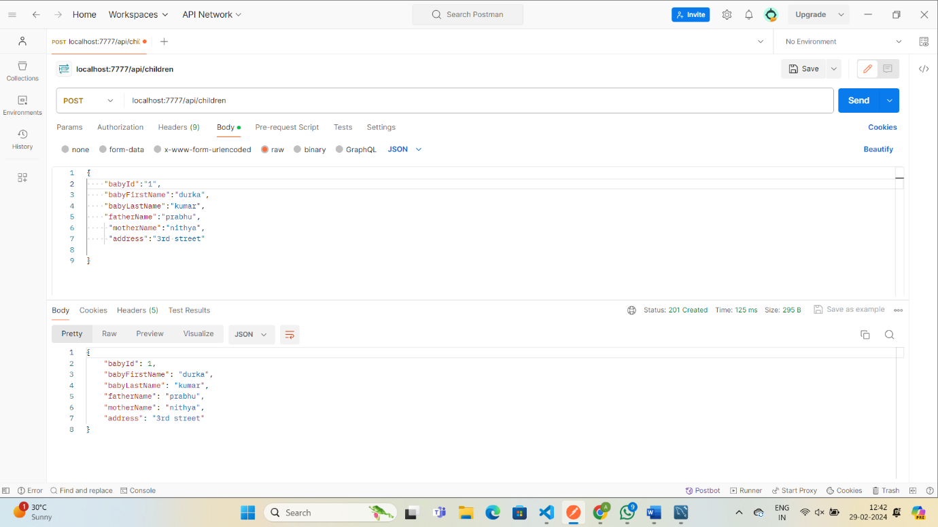

    @GetMapping("/api/children/sortBy/{field}")

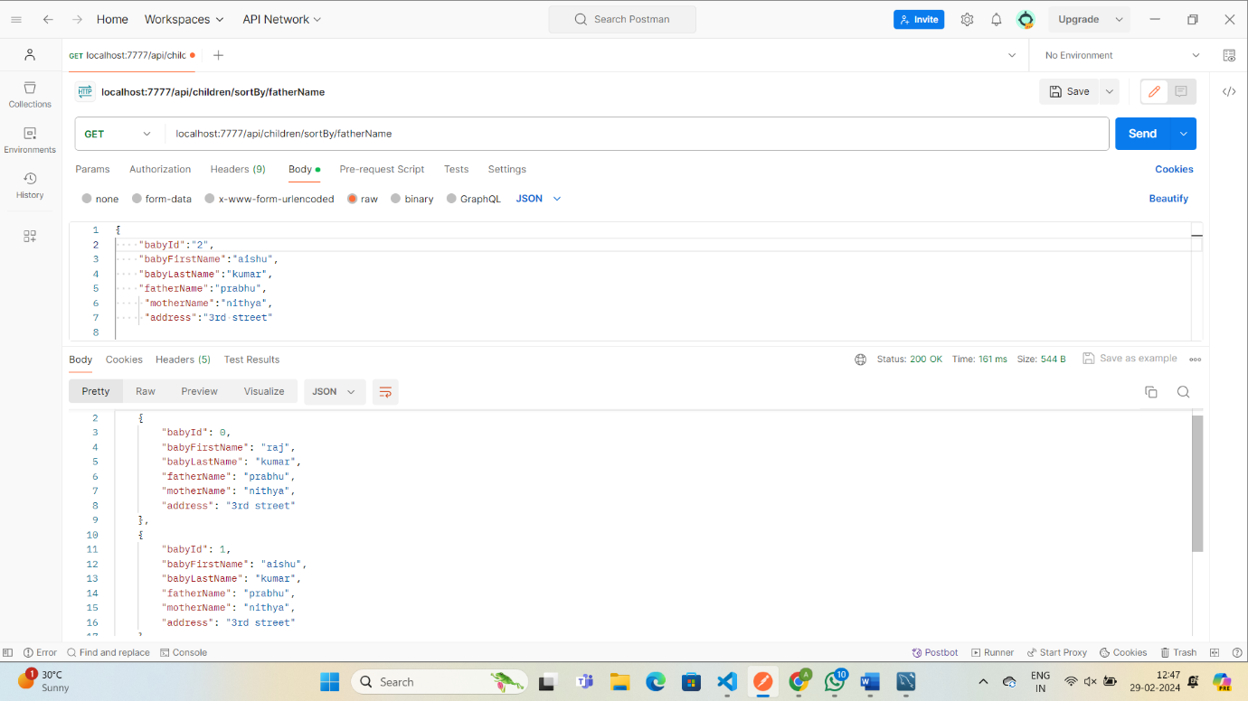

GetMapping("/api/children/{offset}/{pagesize}")

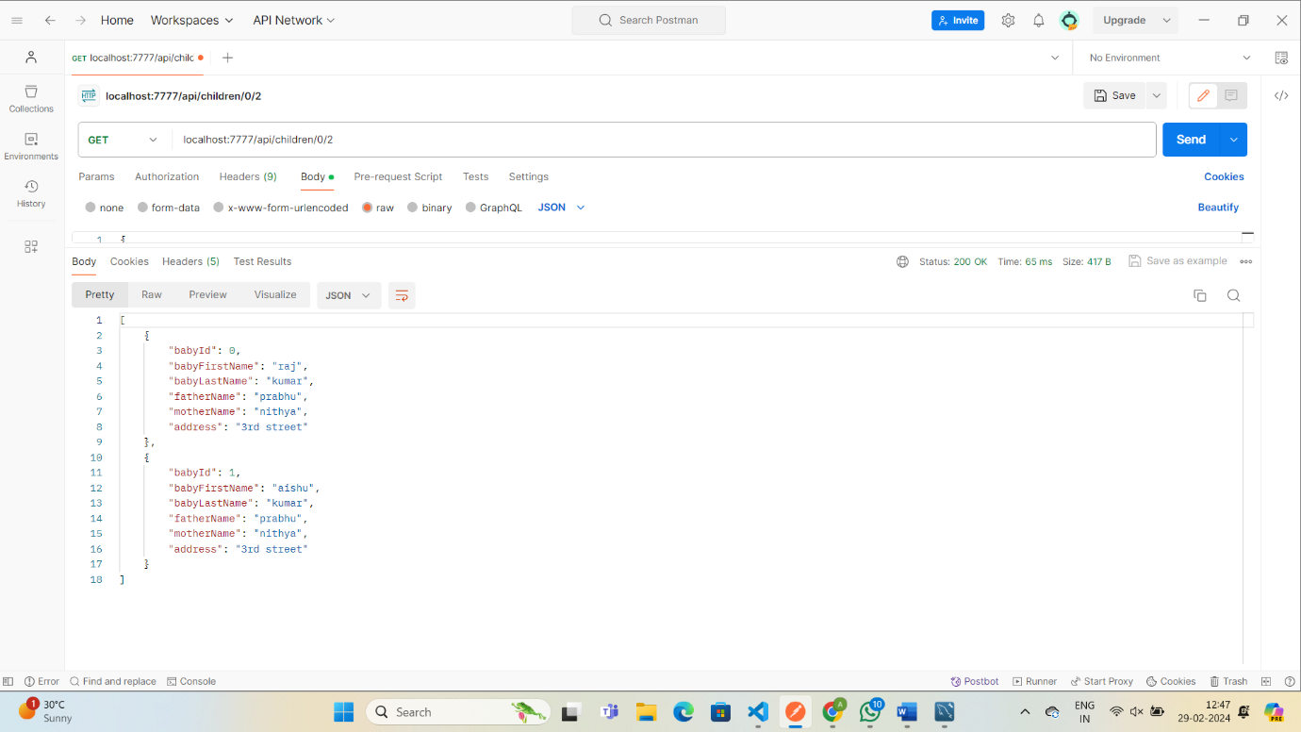

@GetMapping("/api/children/{offset}/{pagesize}/{field}")

